Project Design Phase-II
Data Flow Diagram & User Stories

Date | 28 September 2026
Team ID | 6ab2210011b716a3e52c62c6
Project Name | Streamlining IT Procurement: Automating Standard Laptop Orders with Flow Designer
Maximum Marks | 4 Marks

Data Flow Diagrams:
The Data Flow Diagram represents how a standard laptop request moves through the automated procurement system. The employee submits the request through the Service Catalog. The Service Catalog triggers the Flow Designer workflow, which automatically creates a catalog task for the IT procurement team. The procurement team processes the request and completes the laptop order. This reduces repeated manual work and improves the consistency of task processing.

Data Flow | Description
IT Employee → Service Catalog | Employee submits a standard laptop request
Service Catalog → Flow Designer | Request information triggers the automated flow
Flow Designer → Catalog Task | Flow creates a procurement task automatically
Catalog Task → IT Procurement Team | Task is assigned for processing
IT Procurement Team → Requester | Order status / completion information is provided

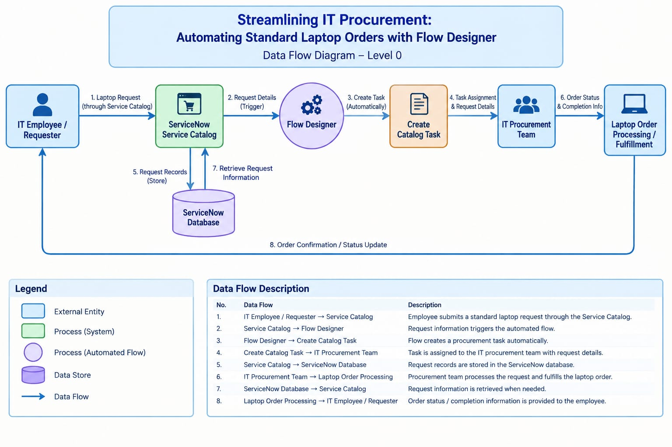
User Stories
Use the below template to list all the user stories for the product.
User Type | Functional Requirement (Epic) | User Story Number | User Story / Task | Acceptance Criteria | Priority | Release
IT Employee / Requester | Standard Laptop Request | USN-1 | As an employee, I can submit a standard laptop request through the Service Catalog. | The laptop request is submitted successfully with the required details. | High | Sprint-1
IT Employee / Requester | Standard Laptop Request | USN-2 | As an employee, I can provide the required information for my laptop request. | Required request details are captured correctly. | High | Sprint-1
IT Procurement Team | Automated Task Creation | USN-3 | As a procurement team member, I can receive a catalog task automatically after a laptop request is submitted. | A catalog task is created automatically for the submitted request. | High | Sprint-1
IT Procurement Team | Request Processing | USN-4 | As a procurement team member, I can process the standard laptop order using the created task. | The task contains the related request information needed for processing. | High | Sprint-1
IT Procurement Team | Workflow Automation | USN-5 | As an IT procurement team member, I can use an automated workflow instead of manually creating repeated tasks. | Flow Designer automatically creates the required catalog task. | High | Sprint-1
Administrator | Flow Management | USN-6 | As an administrator, I can configure the Standard Laptop Task flow in Flow Designer. | The flow is saved, activated, and runs when the request is submitted. | Medium | Sprint-2
Administrator | Flow Monitoring | USN-7 | As an administrator, I can monitor the execution of the laptop procurement flow. | The flow execution and created task can be verified successfully. | Medium | Sprint-2

